Treasure Box Braille Scenario Editor

User Manual

# Application requirements

## Required:

* Java JRE 1.8 or higher
* http://www.oracle.com/technetwork/java/javase/downloads/server-jre8-downloads-2133154.html

## Optional:

* NVDA - NonVisual Desktop Access
* https://www.nvaccess.org/download/

# Installation instructions:

## Standard installation:

The Treasure Box Braille Scenario Editor application is delivered in a .zip archive file.

Once the TBB.zip file is extracted, locate and open the TBB folder.

Inside the TBB folder is a runnable JAR file.

Running TBB.jar opens the application.

## (Optional) Installing NVDA:

Open the installer obtained from the link above.

Follow the installation wizard steps to install NVDA.

Java Accessibility Bridge must be enabled in Windows.

Ease of Access Center > Use the Computer without a display > Other programs installed > Enable

## Troubleshooting:

To run the application from a terminal, use the command “java -jar TBB.jar”.

Ensure that the TBB_lib folder is in the same folder as the TBB.jar.

Contents

Application requirements 1

Required: 1

Optional: 1

Installation instructions: 1

Standard installation: 1

(Optional) Installing NVDA: 1

Troubleshooting: 1

Software features: 3

Application Overview 3

Ribbon Menu Bar 4

File 4

Edit 5

Help 5

Editor Panel 6

Text Template 8

Question Template 8

Audio Template 9

Braille Template 9

# Software features:

## Application Overview

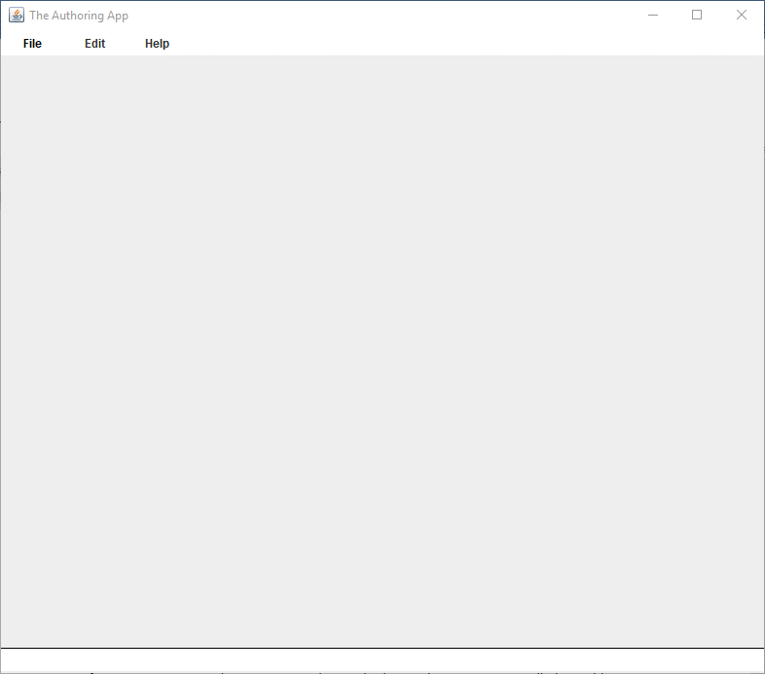

## Ribbon Menu Bar



This ribbon menu allows the user to navigate options in preparation for opening, editing, and playing scenario files for the Treasure Box Braille system.

### File



This tab allows the user to access file related functions.

#### Open Scenario



This button allows the user to open a scenario file from the file system

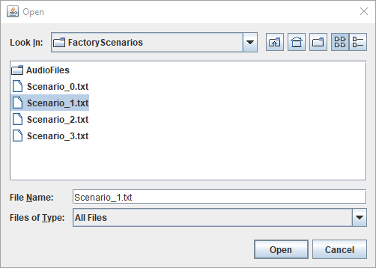



This label allows the user to know what file is currently loaded in the Treasure Box Braille Scenario Editor.

#### Create Scenario



This button allows the user to create a new scenario file.

This function is currently not implemented

#### Play Scenario



This button allows the user to play the scenario file in the Treasure Box Braille Player.

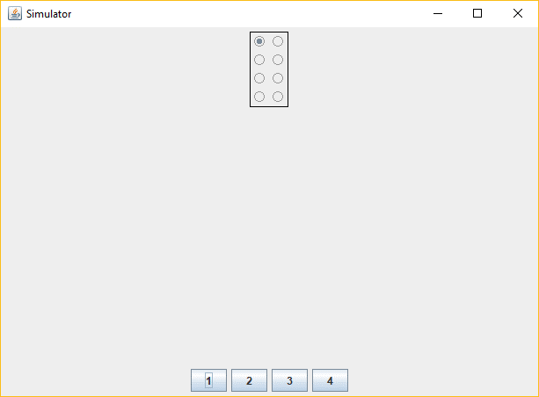

### Edit





This button allows the user to edit the loaded scenario file in the editor panel below.

### Help



Opens https://github.com/marlinla/Treasure-Box-Braille/blob/master/Documentation/User%20Manual.pdf where the Treasure Box Braille Scenario Editor User Manual could be found.

## Editor Panel

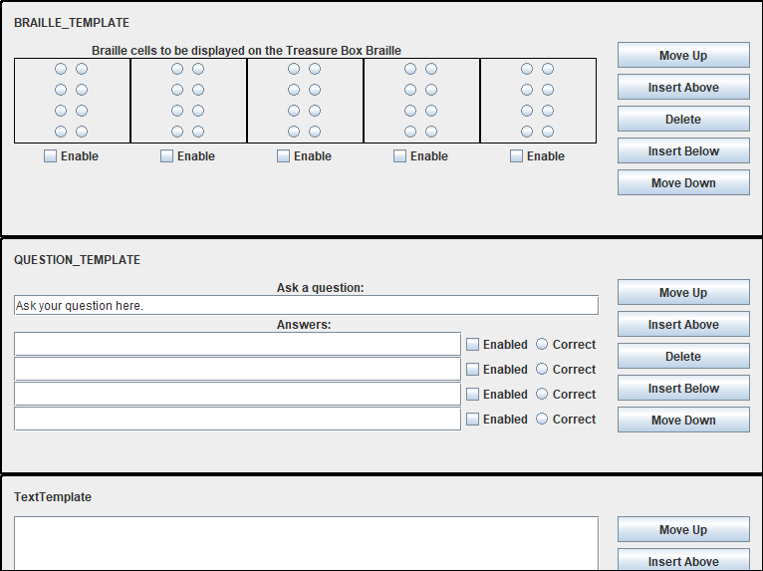

The editor panel allows the user to manipulate templates to quickly formulate educational materials for the Treasure Box Braille Player.

#### Move Up



This button allows the user to move the current template up.

#### Insert Above



This button allows the user to insert the template of their choice above this template

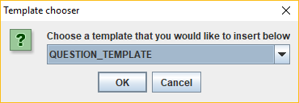

#### Delete



This button allows the user to delete the current template

#### Insert Below



This button allows the user to insert the template of their choice above this template

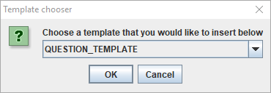

#### Move Down



This button allows the user to move the current template down.

### Text Template

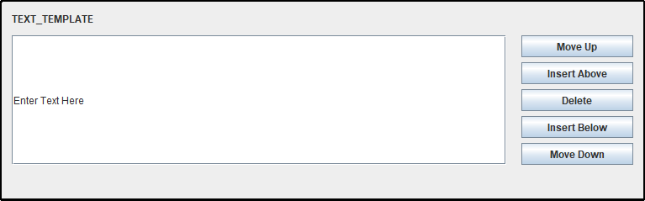

The text template allows the user to create text lines that are read aloud by the Treasure Box Braille Player.

This is the template that is currently created for each line in an opened scenario file.

### Question Template

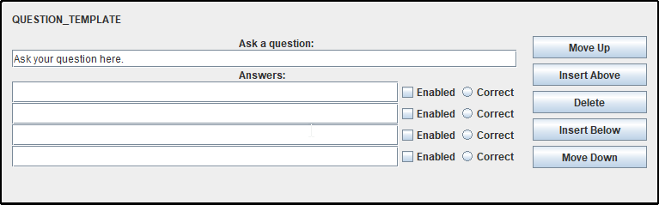

The question template allows the user to create questions for the scenario reader which the Treasure Box Braille Player will ask the listener.

Up to 4 answers can be chosen. Only one answer can be chosen as correct, and the Treasure Box Braille Player will repeat the question until the current answer is chosen.

Suitable for multiple choice style reinforcement.

This template currently not fully Implemented.

### Audio Template

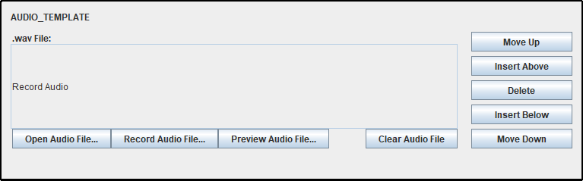

The audio template allows the user to insert audio files to be played by the Treasure Box Braille Player. The file name will be displayed in the text field but cannot be edited manually.

This template is currently not fully implemented.

### Braille Template

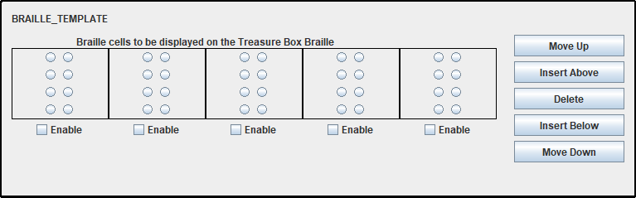

The Braille template allows the user to display Braille cells by the Treasure Box Braille Player.

1-5 extended Braille cells can be used.

This template is currently not fully implemented